Lab 3: Containerization and Cluster

Orchestration

Name : Mazen Yassar

Group : SE2

Part A – Namespaces and cgroups
task A1-1 - Start an interactive container
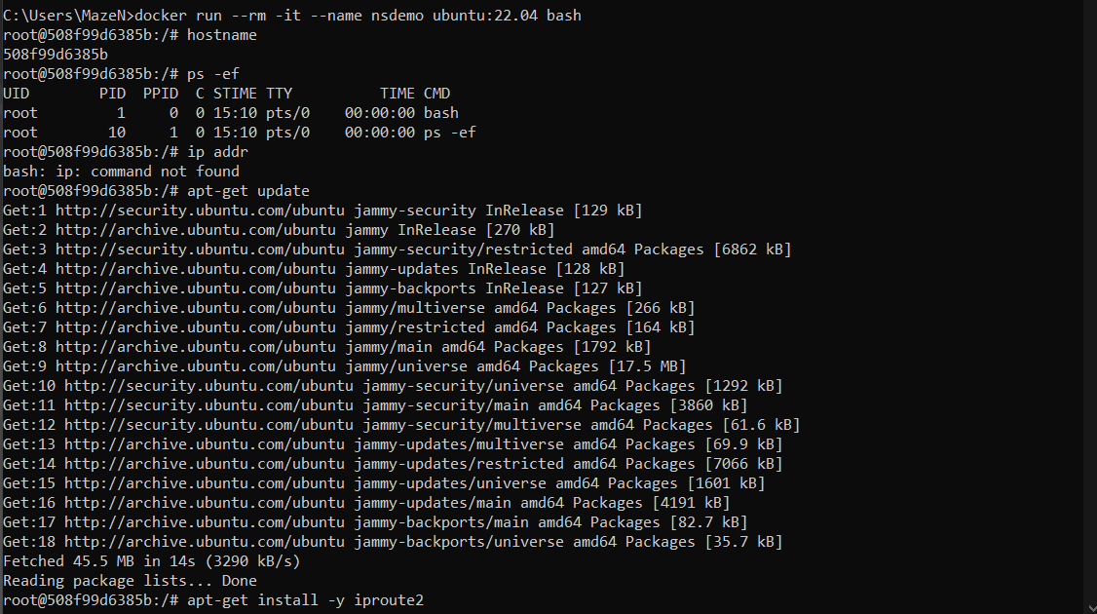
task A1-2
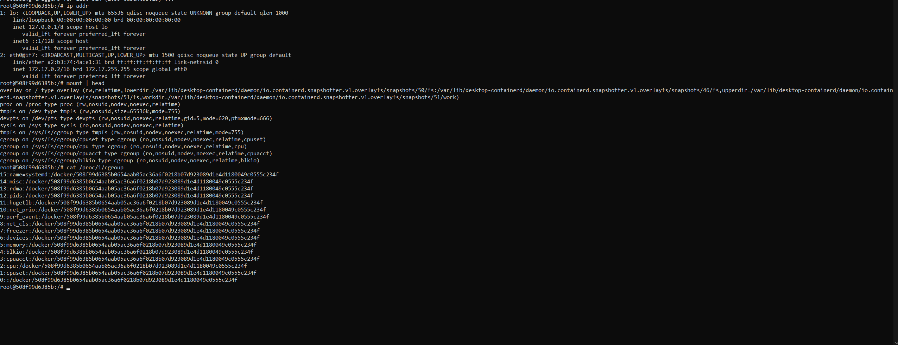

task A2-1 - compare host and container process view
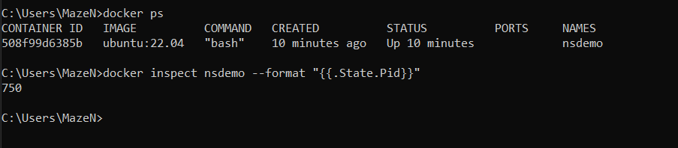
task A2-2
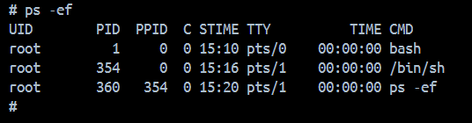
task A3 - Apply resource limits with cgroups
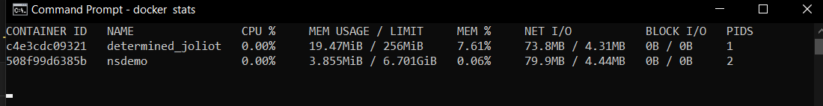

Part B – Docker image layering
task B2-1 - Build a basic image
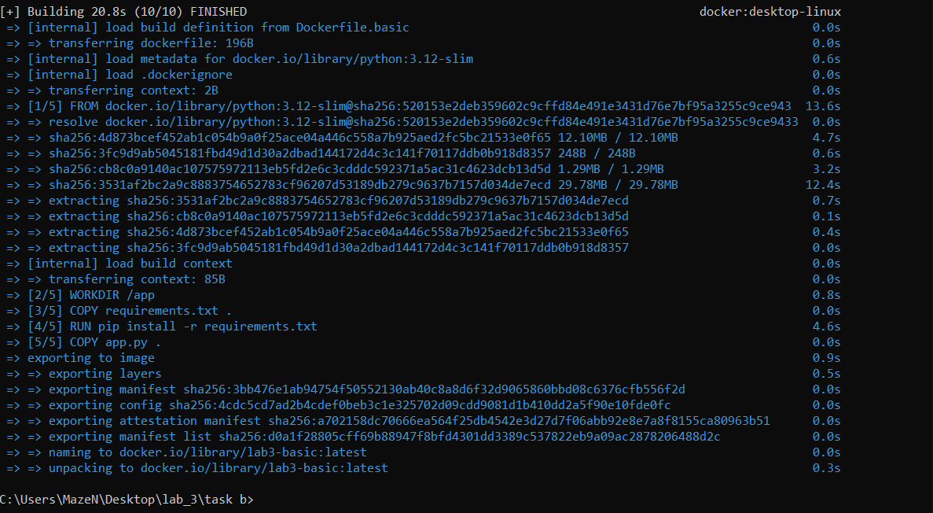
task B2-2
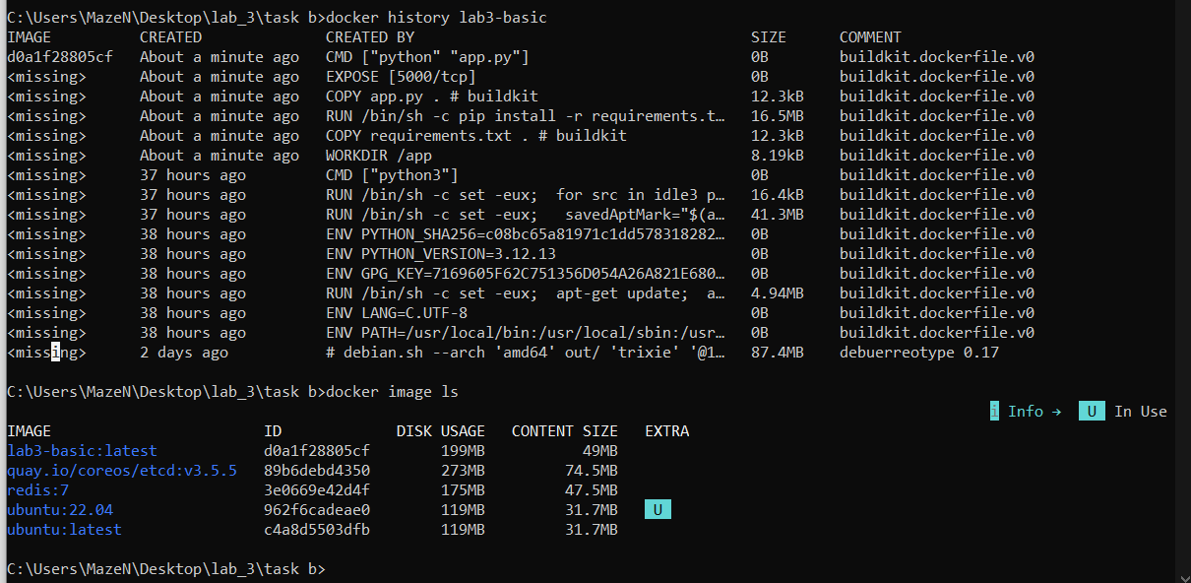

task B3-1 - Build a multi-stage image
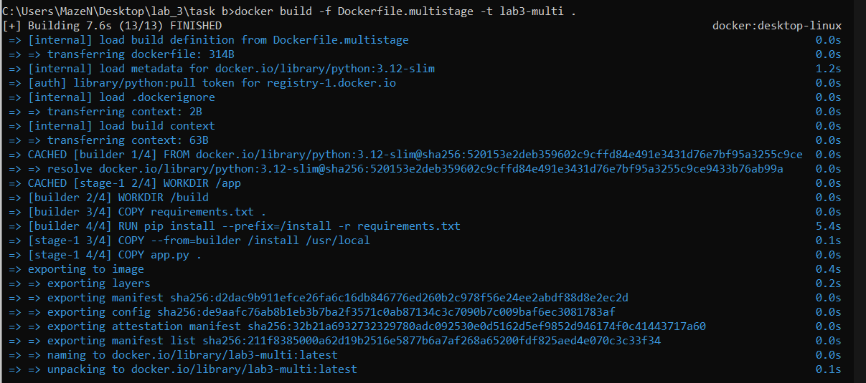
task B3-2
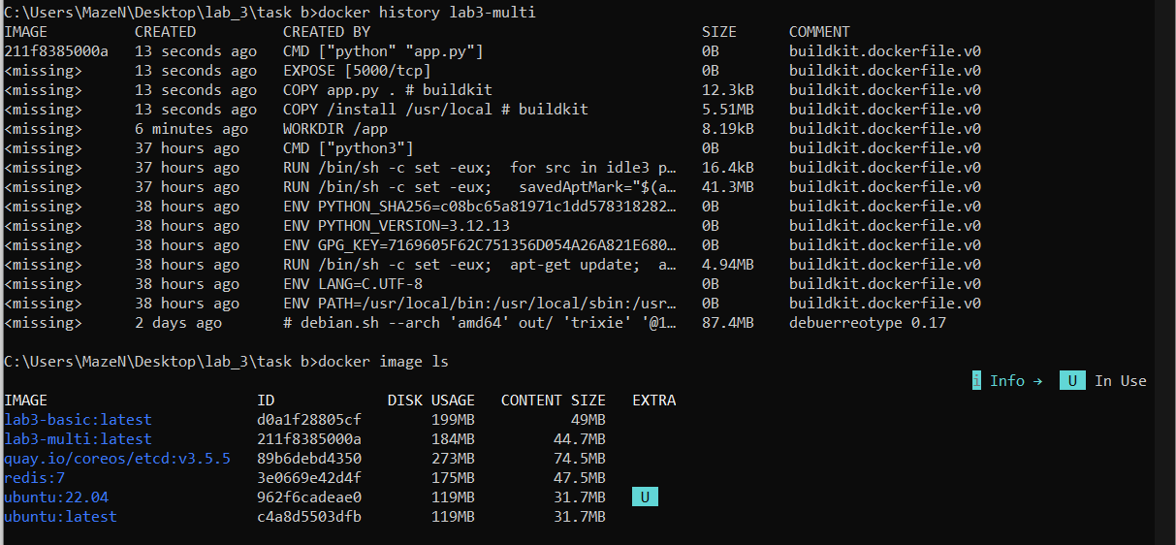

Part C – Kubernetes with kind
task C1-1 - Create a local cluster
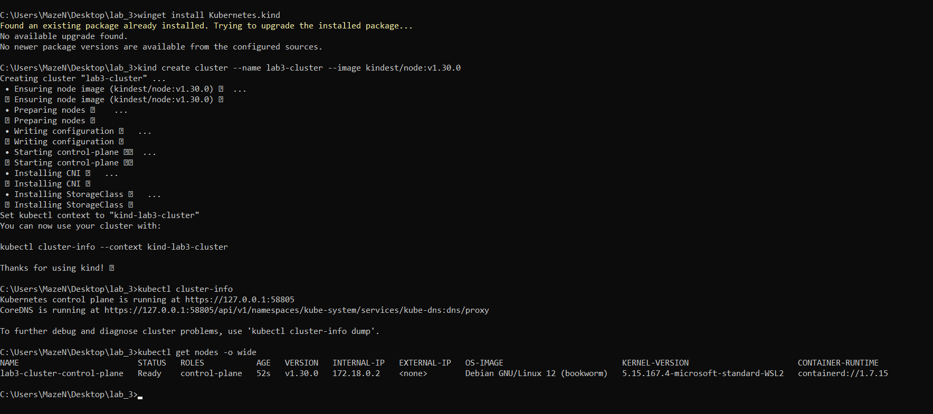
task C2 - Load your image into kind
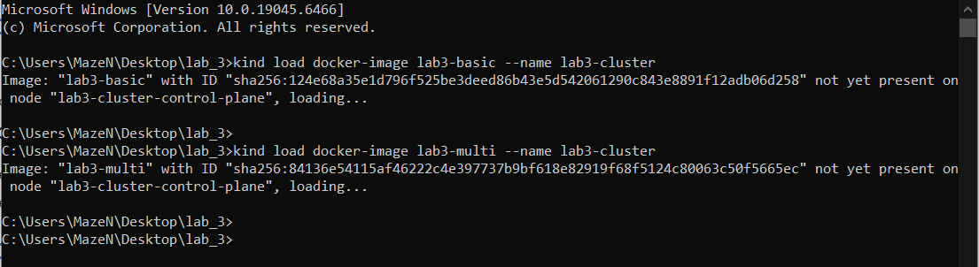
task C3-1 - Deploy a replicated application
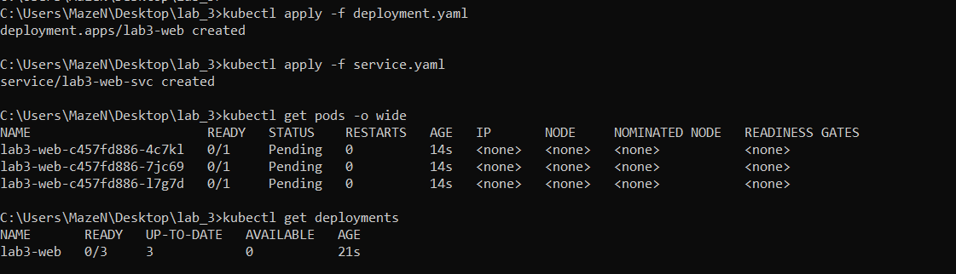

task C3-2
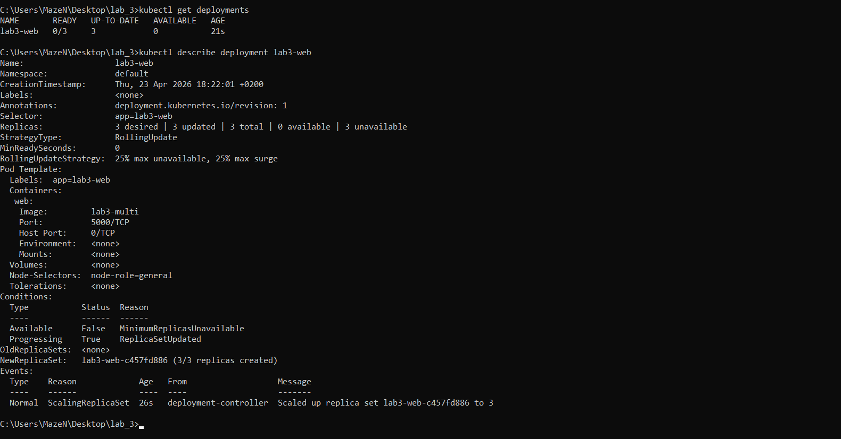
task C4-1 - Access the service
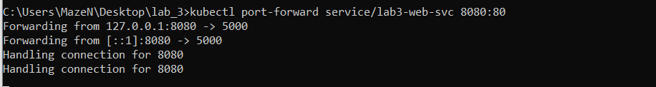
task C4-2
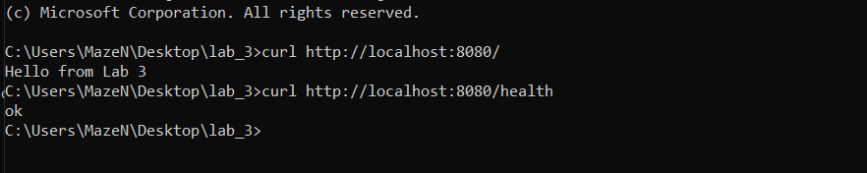

Part D – Scheduling and placement
task D1 - Label the node
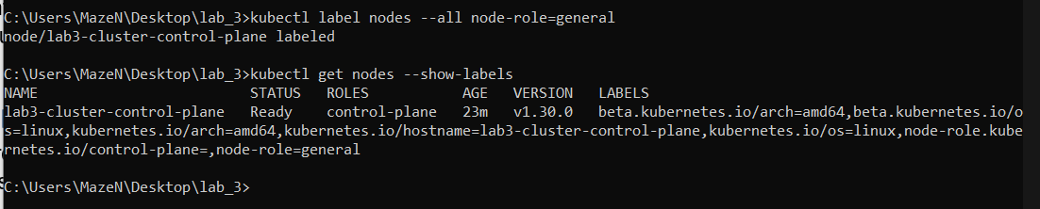
task D2 -
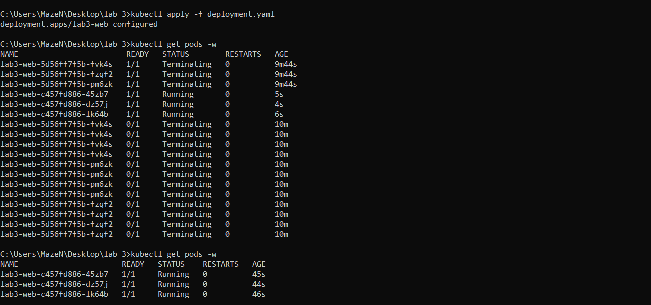

Part E – Self-healing and probes
Evidence screenshots for Part E – Self-healing and probes.
task E1 - Trigger self-healing by deleting a Pod
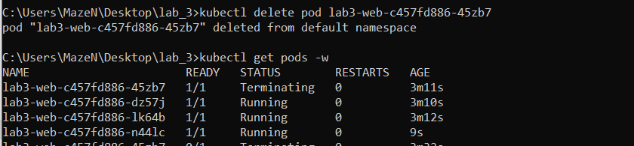
task E2-1 - Add readiness and liveness probes
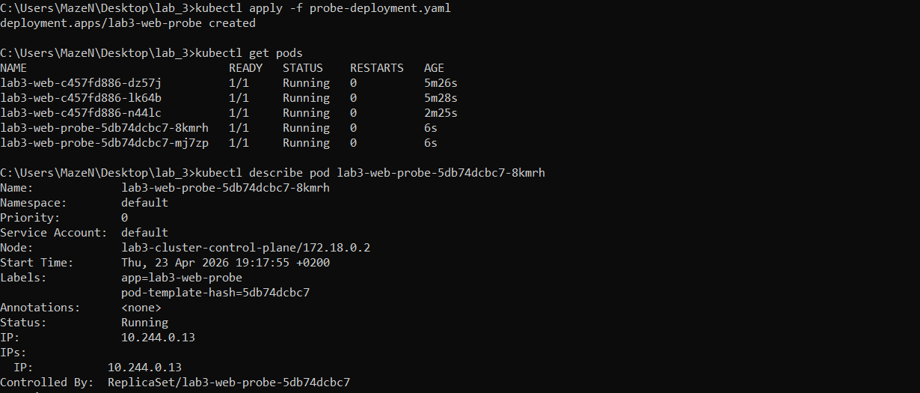

task E2-2
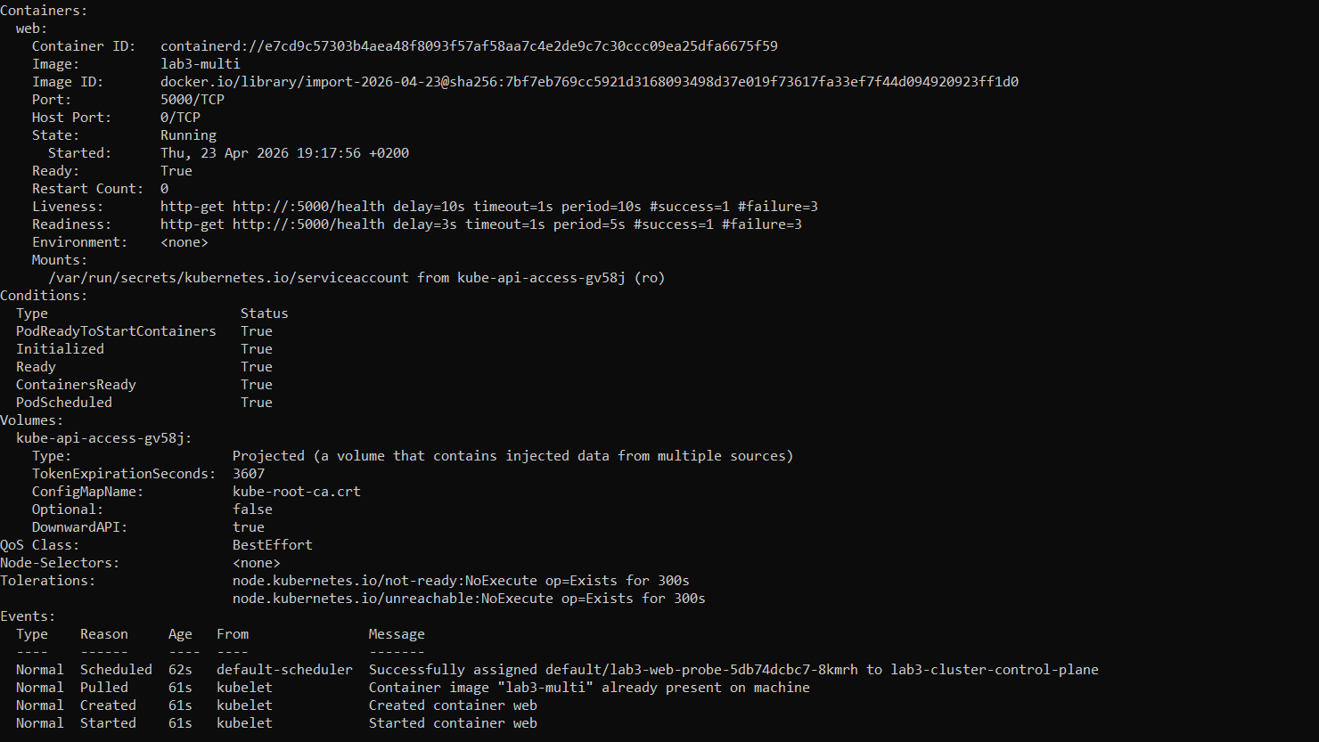
task E3- Observe what happens if the container process dies
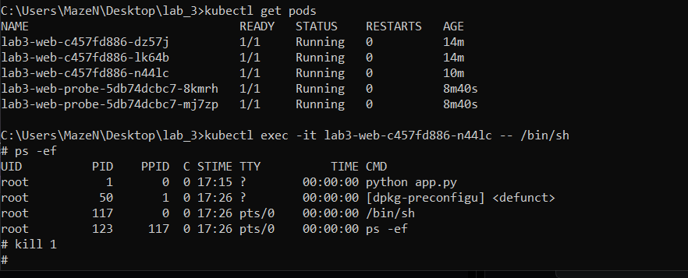

Answers to Questions

- Why does the container think its main process is PID 1 while the host sees a different PID?
Because the container runs in its own PID namespace. Inside that namespace, the first process becomes PID 1, while the host still sees the real host PID.

- How do cgroups complement namespaces?
Namespaces isolate what a process can see and access, while cgroups control how much CPU, memory, and I/O it can consume.

- Which image is smaller? Which steps are cached if only app.py changes? Why does layer order matter?
The multi-stage image is usually smaller because build-only artifacts are left behind. If only app.py changes, the dependency install layers are cached and only COPY app.py and later layers rebuild. Layer order matters because stable steps placed earlier maximize cache reuse.

- Why is declarative scheduling better than hard-coding machine names?
Using labels/selectors lets Kubernetes place workloads on any suitable node. This improves resilience, scaling, and maintenance because workloads are not tied to one machine.

- Why is Pod replacement called reconciliation rather than simple restart logic?
Kubernetes compares actual state with desired state. If one Pod disappears, controllers create a replacement to restore the declared replica count.

- Did Kubernetes restart the container in place or create a new Pod after kill 1?
Usually kill 1 causes the container in the existing Pod to restart according to the Pod restart policy. Deleting the whole Pod causes a brand-new Pod to be created by the Deployment.

Reflection Questions
1. Namespaces alone do not guarantee fair resource use because they isolate resources but do not limit consumption.
2. Cgroups improve cluster stability by enforcing CPU, memory, and other limits so one container cannot starve others.
3. Docker image layering reduces build time, storage, and network transfer through layer reuse and caching.
4. Desired state is the target configuration Kubernetes continuously tries to maintain.
5. Self-healing means the platform automatically restarts or replaces failed workloads without manual intervention.
6. Readiness probes control traffic routing; liveness probes detect unhealthy containers and trigger restarts.
7. A single-node kind cluster cannot demonstrate real multi-node placement, balancing, or failure-domain scheduling.

